Dr. Michael Burry — Part one: Starting small
Like many of the great value investors, few have heard of Dr. Michael Burry outside of value circles. However, Michael Burry wasn’t just a standard value investor; he was one of the first — possibly the first — hedge fund manager to bet against the subprime housing market. In addition, Michael Burry was instrumental in creating a market for credit default swaps, which allowed other investors to bet against the subprime mortgage market.

Starting small
Michael Burry first started to take a serious interest in the market while he was doing his medical residency at Stanford Hospital. The dotcom bubble was reaching its height, and Michael Burry wanted to know why the market was acting so irrationally.
After 16-hour shifts at the hospital, he would work on his investments and blog, posting stock-market trends and his opinion for making trades. These blog posts were well research and thorough. Soon they started to attract attention, although Burry unaware at first.
The first time Michael Burry realized that other people were reading his work, was when he wrote a post criticizing Vanguard and some of their funds. Soon after, a cease and desist letter arrived from Vanguard’s lawyers.
Soon after, Burry left medicine and started his fund. Named Scion Capital, the fund was started with a small investment from Burry’s family members. But before Burry has even begun to allocate his newly found capital, he received a phone call from Gotham Capital, founded by Joel Greenblatt, which, as it turns out had been following his trades for some time and wanted to invest. At the same time, Michael Burry also received a call from insurance group, White Mountains, which offered him $10 million to invest and a further $600,000 to buy a share of Scion.
After being in business for only a few weeks, with no background in the fund management industry, Michael Burry’s Scion Capital was managing money for some of the most respected investors around.

Investment philosophy
Michael Burry’s investment philosophy is very different from that of other value investors. Contrarian in nature, Burry was on the lookout for unloved, unknown companies with an upcoming catalyst. In the same way that Graham and Schloss shunned management and outside opinions, in favor of their own rigorous analysis of balance sheets, Burry conducted all of his research online. Sitting alone in his offer with the blinds shut he looked for investments. According to Michael Lewis’ book, The Big Short, Burry employed analysts at Scion but failed to find a use for them. He often conducted all of the work himself.
Michael Burry’s investment philosophy was to look for what he called the “ick factor.” Essentially companies suffering from serious problems, but which are still, good investments:
My strategy isn’t very complex. I try to buy shares of unpopular companies when they look like road kill, and sell them when they’ve been polished up a bit. Management of my portfolio as a whole is just as important to me as stock picking, and if I can do both well, I know I’ll be successful.
Weapon of choice: research
My weapon of choice as a stock picker is research; it’s critical for me to understand a company’s value before laying down a dime…All my stock picking is 100% based on the concept of a margin of safety, as introduced to the world in the book “Security Analysis,” which Graham co-authored with David Dodd. By now I have my own version of their techniques, but the net is that I want to protect my downside to prevent permanent loss of capital. Specific, known catalysts are not necessary. Sheer, outrageous value is enough.
I prefer to buy within 10% to 15% of a 52-week low that has shown itself to offer some price support. That’s the contrarian part of me. And if a stock — other than the rare birds discussed above — breaks to a new low, in most cases I cut the loss.
I also invest in rare birds — asset plays and, to a lesser extent, arbitrage opportunities and companies selling at less than two-thirds of net value (net working capital less liabilities). I’ll happily mix in the types of companies favored by Warren Buffett — those with a sustainable competitive advantage, as demonstrated by longstanding and stable high returns on invested capital — if they become available at good prices.
“…I like to hold 12 to 18 stocks diversified among various depressed industries, and tend to be fully invested. This number seems to provide enough room for my best ideas while smoothing out volatility, not that I feel volatility in any way is related to risk…”
This approach it seems, worked extremely well.
In its first full year of trading, 2001, Scion returned 55.44% gross for its investors. The S&P 500 fell 11.88% over the same period. In 2002, Scion returned 16.08% gross for its investors, compared to the S&P 500’s -22.10%. And in 2003 the fund once again returned over 50% gross, beating the S&P 500by 22.02% for the year.
Due to his continuous success, Scion Capital had $600 million AUM at the end of 2004 and Burry was turning money away.
From its inception in 2000, through to closing during 2008, Scion returned 696.94% gross and 472.40% net compared to the S&P 500, which returned 5.2% over the same period.
At its height, Scion managed about $1 billion.

Subprime risks
Michael Burry was one of the few hedge fund managers to spot the risks the subprime mortgage boom posed to Wall Street and indeed the whole global financial system. In fact, Burry started to take notice of the subprime market and its failings as early as 2005 and was instrumental driving Wall Street’s big players to create credit default swaps specifically linked to subprime bonds. Michael Burry discovered that many subprime loans were being offered with two-year teaser rates.
After the two year period was up, interest rates jumped from an artificially low teaser rate, up to a floating rate the borrower would be unable to pay. The result Burry predicted would be a wave of subprime loan defaults in 2007, two years from when the loans were issued during 2005.
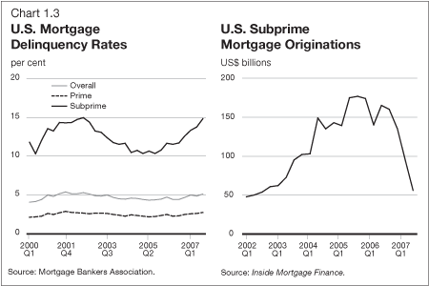
Michael Burry acquired several hundred million dollars’ worth of subprime CDS’s from 2005 to 2007, and this greatly upset his investors. What was a value investor doing betting almost all of Scion’s funds against the trillion dollar subprime mortgage market? Even Joel Greenblatt, one of Burry’s original investors flew out to meet Burry directly and demand his money back.
After years of fighting with his investors, eventually, the bet paid off, and Scion Capital returned 166.91% gross for investors during 2007, after losing 18.16% during 2006. Burry sold out of his CDS position and shuttered Scion during the first half of 2008, after the turbulence of the preceding years.
From its inception in 2000, through to closing during 2008, Scion returned 696.94% gross and 472.40% net compared to the S&P 500, which returned 5.2% over the same period.

Stock selection
Scion’s performance over its short life is Burry’s greatest accomplishment and it was Burry’s detailed research that lead to these returns. In fact Michael Burry’s research is some of the most detailed and thorough. Reading though it will almost certainly improve your investing process. So stay tuned for part two where I’m going to take a more detailed look at Michael Burry’s research process.

Dr. Michael Burry — Part two: How much can I lose?
“Ick investing means taking a special analytical interest in stocks that inspire a first reaction of ‘ick.’ I tend to become interested in stocks that by their very names or circumstances inspire unwillingness – and an ‘ick’ accompanied by a wrinkle of the nose on the part of most investors to delve any further.”
“Fully aware that wonderful businesses make wonderful investments only at wonderful prices, I will continue to seek out the bargains amid the refuse.” — Dr. Michael Burry
There are some great examples of Burry’s investments while he was running Scion. A classic value play was Wellsford Real Properties (WRP). Originally, I was going to cover several of Michael Burry’s classic investments in this piece, but looking at Burry’s thesis for the Wellsford trade has taken up this entire article — even with several thousand words cut out. So I’ll take a look at some of Michael Burry’s other investments in parts three and four of this series. For the time being, here’s Wellsford:
Wellsford Real Properties(WRP) – $16.60 on Jun 1, 2001
WRP is an opportunity to buy real estate at as little as 50 cents on the dollar (and at most 61 cents on the dollar), with a plan for value realization in place and virtually no downside. Wellsford Real Properties is a real estate operating company (REOC) and as such its value is in wealth creation rather than earnings distribution…The stock’s at $16.50. Book value is $26.93 and understates true net asset value…Here’s why:
Wellsford is an incomplete liquidation story now divided operationally into three strategic units:1) Wellsford Commercial ($10/share book value, liquidating, no recourse debt) – primary asset is a 39% interest in Wellsford/Whitehall, a joint venture with Goldman, valued at 86 million at March 31st. This value will continue to increase. W/W has been in the business of buying up turnaround properties and putting some sweat equity into them, then filling them.
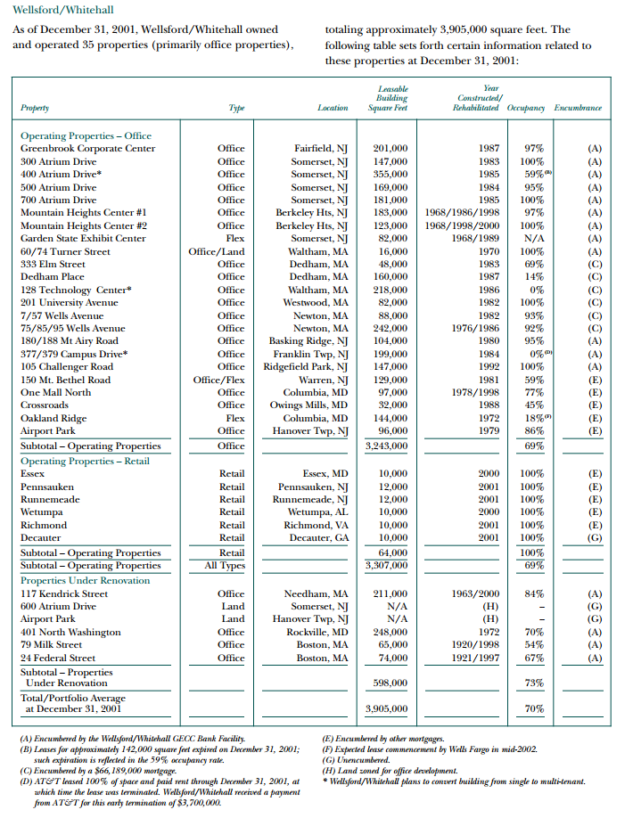
2) Wellsford Capital ($12/share book value; continuing; no recourse debt) -As the real estate market peaks, the Chairman wants to get out of equity, but sees future potential for buying real estate debt on the cheap as things turn sour…yet by buying smart earn great returns despite not taking on substantial risk.a) $35.4 mill direct investment in 11.5% meezzanine loan, 277 Park Avenue (DLJ’s building, well known to some of you I’m sure ‘hedge fund hotel’)
b) 51% interest in Second Holding, LLC, another JV that invests in real estate debt. They have been ramping this up. Carried at equity method and equity in Second Holding is roughly $27 mill. That’s the limit of their liability…Again, the equity value at risk here is only a little over $3/share.
c) $7 mill investment in REIS, a real estate information services company – I write this down simply because there’s a family relation behind this investment, but it is possible the 6.9 million may even underrepresent the value of that asset.
d) VLP is being liquidated – another $11 million or so to come.
…because of the nature of the turnaround properties, I don’t anticipate much long-term downside there from the book level. Potential losses in Capital are maybe $3/share in book value…
The company has been buying back shares when blocks become available, retiring 2 million shares in this fashion in the last couple of years. The Chairman vows to continue doing so, claiming the illiquidity of the stock is the greatest impediment – he doesn’t want to run it up…
The history of Wellsford is that management presided over Wellsford Residential Property Trust – of which WRP was a subsidiary – from 1992-1997. The Trust merged with Equity Residential Properties at a price that gave a 23% annualized return since inception to shareholders. The stock had done nothing for years….
Franklin Mutual (Beacon, Qualified) owns 24% of the common from the initial private placement, and Morgan Stanley owns 17% of the common from the same. Neither have been buyers recently. MJWhitman Advisors upped its position 25% during the 1st Q.
A decent sized seller (probably Fleet or Advisory Research or both) has been offering shares whenever adecent-sized order comes up to buy, so in my experience at least the illiquidity is less a problem than it appears.
Catalyst
Liquidation of real estate per plan with $200 million in properties being marketed for sale right now; possible sale of whole company; commitment to share buyback at deep discount to intrinsic value; dollar on sale for 50-60 cents with no significant downside; possible Russell 2000 inclusion on June 30th but is one of the few such candidates that hasn’t really moved yet.
The whole Wellsford Real Properties thesis can be found here. At the link, there’s also a string of comments covering how the investment thesis developed over time. Wellford merged with Reis during 2007.
This is rigorous analysis by any standard. Michael Burry looked at every possible avenue and outlook for different parts of the business, its history and current shareholders. There’s no stone left unturned, but Michael Burry mainly concentrates on the potential downside for each section of the Wellsford business. Indeed, Michael Burry assess each business under the Wellsford Real Properties umbrella and computes the potential downside on a per-share basis. This is something Michael Burry specialized in.
Michael Burry always approached each investment thinking “how much can I lose”, rather than the standard approach used by the majority of asset managers, investors and fund managers, (re: The Little Book of Behavioral Investing) “how much can I make”.
I’m going to take a closer look at some of Michael Burry’s other investments in part three of this series so stay tuned!
- Dr. Michael Burry — Part three: Looking for bargains
Michael Burry used a detailed approach to finding investments, which involved several different angles of attack. Firstly, Burry looked for value by focusing on free cash flow and enterprise value. To find prospective investments, Michael Burry would screen the market looking specifically at the enterprise value/EBITDA ratio (investing based on the EV/EBITDA ratio has been shown to outperform other valuation metrics over time).
After establishing a rough idea of where to look, Michael Burry:
“I’ll then look harder to determine a more specific price and value for the company. When I do this I take into account off-balance sheet items and true free cash flow. I tend to ignore price-earnings ratios. Return on equity is deceptive and dangerous. I prefer minimal debt, and am careful to adjust book value to a realistic number.”
Minimal debt, a low P/B ratio (adjusted to reflect realistic asset values), strong free cash flow and low EV/EBITDA ratio were the four traits Michael Burry looked for in an investment.
Secondly, Michael Burry looked for what he called ‘rare birds’, or asset plays in other words. Thirdly, Burry looked for value in the type of company favored by Buffett. (Those with a sustainable competitive advantage as demonstrated by longstanding and stable high returns on invested capital, although only at a reasonable price.)
Lastly, Michael Burry liked to buy what he called “ick” investments. One such example is given Michael Lewis’ book: The Big Short:
“He went looking for court rulings, deal completions, or government regulatory changes — anything that might change the value of the company…The alarmingly named Avant! Corporation was a good example. He found it searching for the word ‘accepted’ in news stories…’I was looking to get in front of something. I was looking for something happening in the courts that might lead to an investment thesis. An argument being accepted, a plea being accepted, a settlement being accepted by the court.’
A court had accepted a plea from a software company called the Avant! Corporation. Avant had been accused of stealing from a competitor the software code that was the whole foundation of Avant!’s business. The company had $100 million in cash in the bank, was still generating $100 million year of free cash flow — and had a market value of only $250 million!
Michael Burry started digging; by the time he was done, he knew more about the Avant! Corporation than any man on earth. He was able to see that even if the executives went to jail (as they did) and the fines were paid (as they were), Avant would be worth a lot more than the market assumed…Burry bought his first shares of Avant! in June 2001 at $12 per share…Mike Burry kept on buying it — all the way down to $2 a share…Four months later Avant! got taken over for $22 a share. ‘That was a classic Mike Burry trades,’ says one of his investors. ‘It goes up by ten times but first it goes down by half.'”
Unlike almost all other value investors, Burry made use of technical analysis when he was looking for an entry point for his trades:
“As for when to buy, I mix some barebones technical analysis into my strategy…Nothing fancy. But I prefer to buy within 10% to 15% of a 52-week low that has shown itself to offer some price support. That’s the contrarian part of me. And if a stock — other than the rare birds discussed above — breaks to a new low, in most cases I cut the loss…”
This statement runs contrary to the quote above. Although it does show that Michael Burry’s investment decisions were never based on a rigid set of criteria, which only serves to improve his standing as one of the great investors.
Not only did he know when to buy, he also knew when not to sell.
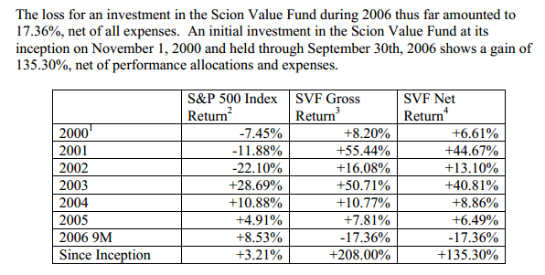

When not to sell
For the most part, Michael Burry’s game-plan in deciding on when not to sell was driven by his desire to maximize downside protection. Always asking the question “how much can I lose?” Michael Burry aimed to beat the S&P 500 over the long run but did not want to take extraordinary risks in order to accomplish this goal:
“…I do not regard my investments here or elsewhere as a contest. Over the long run, I aim to beat the S&P 500, but I will not take extraordinary risks to do it. On a risk-adjusted basis, I’ll obtain the best returns possible. Whom or what I can beat over the next six months is less important to me than providing some insight into how I go about accomplishing my primary long-term goal…”

Portfolio management
Away from stock picking, Michael Burry’s portfolio management was developed through trial and error:
“I like to hold 12 to 18 stocks diversified among various depressed industries, and tend to be fully invested. This number seems to provide enough room for my best ideas while smoothing out volatility, not that I feel volatility in any way is related to risk. But you see, I have this heartburn problem and don’t need the extra stress…I know my portfolio turnover will generally exceed 50% annually… I am not afraid to sell when a stock has a quick 40% to 50% a pop.”
Unfortunately, that’s all have room for in this part. Stay tuned for part four of this series on Dr. Michael Burry. In part four I’ll be taking a closer look at some of Michael Burry’s early investments and discussing why every investor can learn from his style of investing.

Dr. Michael Burry – Value And Quality [Part Four]
In part three of this series, I looked at the methods Michael Burry used to uncover prospective investments. Most of the time, he started with the EV/EBITDA ratio, screening the market for the best bargains. But at the forefront of his decision-making (at all times) was the question “how much can I lose?” Michael Burry believed that limiting risk was the key to long-term success.
In most cases, Michael Burry was able to find opportunities with the least risk where others failed to grasp the true nature of the company involved. Paccar, the world’s third-largest maker of heavy trucks, was a great example.

Hidden value
Paccar operated in a cyclical industry but unlike its peers, the company had adapted to work around this cyclicality. In the early 2000s, Paccar had been profitable for sixty years, and the company had a competitive advantage.
Unlike its peers, Paccar’s truck production was not vertically integrated. Paccar designed the trucks and then assembled them from vendor-supplied parts. This gave the company a ‘nimble’ nature. However, the group also ran a finance division, which was responsible for a huge amount of misunderstanding. As Michael Burry wrote:
“Let’s look at debt
Over the last 14 years, encompassing two major downturns and one minor downturn, Paccar has averaged a 16.6% return on equity. Earnings per share have grown at a 13.2% annualized clip during that time, despite a dividend payout ratio generally ranging from 35% to 70%. Historically, it appears debt is generally kept at its current range of about 50% to 70% of equity.
But the debt is where a big part of the misunderstanding occurs…With a cyclical, it matters.
So we open up the latest earnings release and find that Paccar neatly separates the balance sheet into truck operations and finance operations. It turns out that the truck operations really have only $203 million in long-term debt. The finance operation is where the billions in debt lay. But should such debt be included when evaluating the margin of safety? After all, liabilities are a part of a finance company’s ongoing operations. The appropriate ratio for a finance operation is the equity/asset ratio, not the debt/equity ratio. With $953 million in finance operations equity, the finance equity/asset ratio is 19.5%. Higher is safer. Savings and loans often live in the 5% range, and commercial banks live in the 7-8% range. As far as Paccar’s finance operations go, they are pretty darn conservatively leveraged. And they still attain operating margins over 20…There is also $930 million in cash and equivalents, net of the finance operations cash. The cash therefore offsets the $203 million in truck company debt, leaving net cash and equivalents left over of $727 million. Subtract that amount from the market cap of $3.12 billion to give essentially a $2.4 billion enterprise value…less than the advertised market capitalization…”
This is a message for those investors who screen the market for stocks with a low level of debt. Paccar’s debt/equity ratio showed up on several of Michael Burry’s screens as between 0.7 and 1.8x, which is relatively high for a cycle company but in fact it was quite the opposite. The market had failed to realize this discrepancy.
Michael Burry bought 150 shares of Paccar at the market price on August 2 2000, the company still exists today. Between August 2000 and late 2007, when Michael Burry started to close Scion Capital, Paccar had risen from approximately $8.5 per share at time of purchase, to just under $60 per share, a near 600% return over seven years.
Clearly, I’ve not cherry picked this one successful investment. Something Scion Capital’s performance figures clearly show.
Scion Capital returns

Quality over value
In part three of this series I mentioned that Michael Burry wasn’t just confined to value, he also sought out quality stocks at a reasonable price. One such trade was Caterpillar:
“…Everyone knows that domestic construction is slowing down. I don’t care. Why? Let me explain. Let’s pose that a hypothetical company will grow 15% for 10 years and 5% for the remaining life of the company. If the cost of capital for the company in the long term is higher than 5%, then the life of the company is finite and a present “intrinsic value” of the company may be approximated. But let’s say the cost of capital averages 9% a year. Starting with trailing one-year earnings of $275, the sum present value of earnings over 10 years will be $3,731. If the cost of capital during the remainder of the company’s life stays at 9%, then the present value of the rest of the company’s earnings from 10 years until its demise is $12,324. What should strike the intelligent investor is that 76.8% of the true intrinsic value of the company today is in the company’s earnings after 10 years from now…”
Caterpillar also had a large finance arm, which was skewing debt ratios. Now for the above thesis to play out, you have to be sure that CAT will be around for the next ten years. Michael Burry reached the conclusion that this was likely to be the case.
Indeed, the company was, at the time suffering from a slowdown in US construction activity but the group’s international operations were still growing and non-construction sectors were performing well.
CAT was just one of the few quality and value trades Michael Burry placed over his career.

Conclusion
It’s difficult to try and sum up Michael Burry’s investing career. His style was varied but rigorous. Hopefully, the past few articles have given you some insight into his investment philosophy and show how he was able to achieve market-beating returns while he was running Scion Capital.

